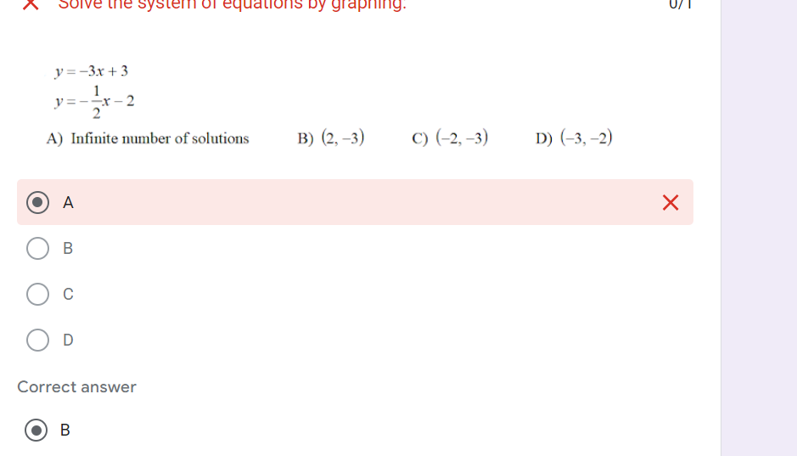

I missed this one because I made my slopes positives when they were really negative. I need to be careful about that in the future

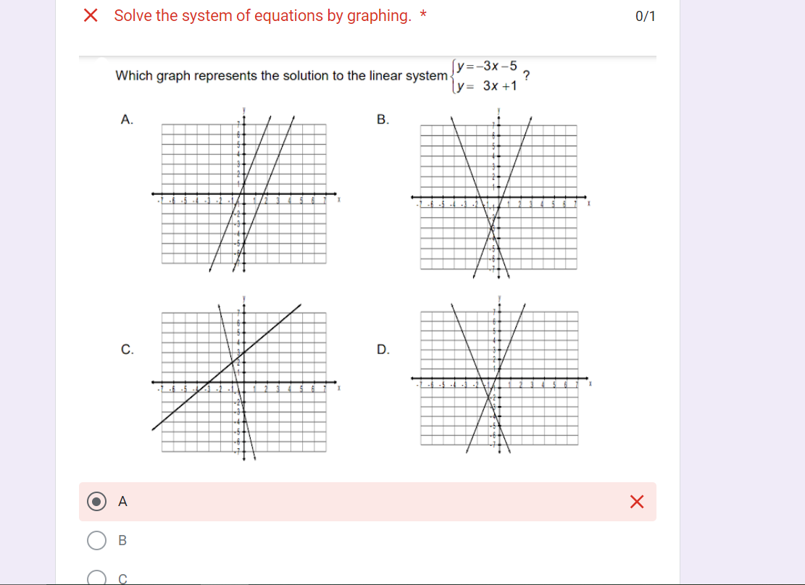

I missed this question because I mixed my negative and positive up.

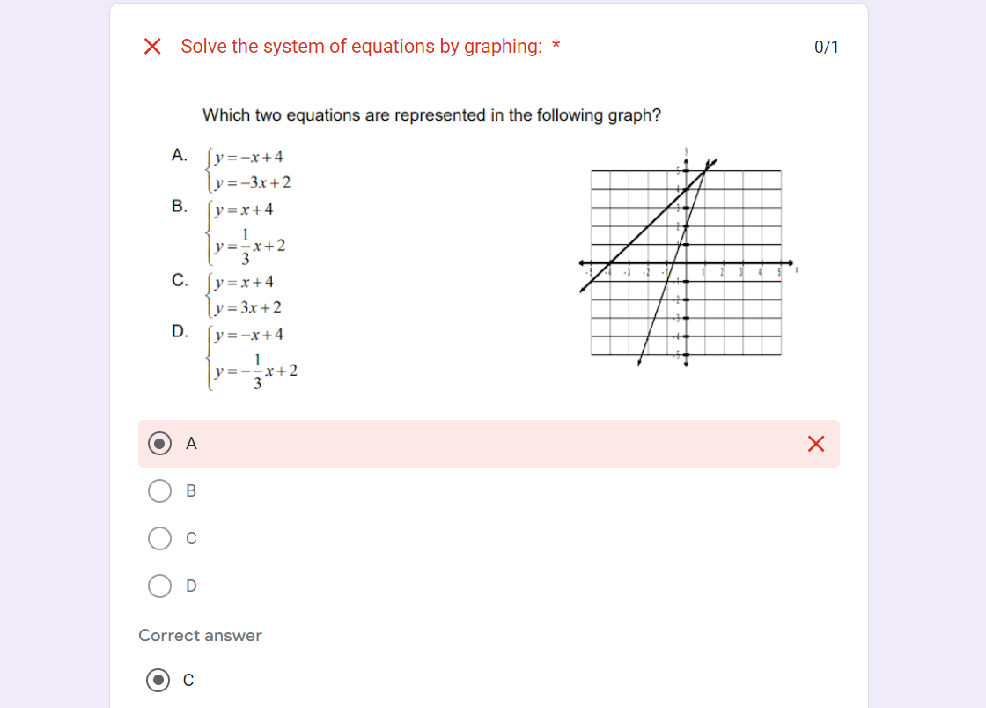

I got this equation wrong because I mixed my graphing up with positive and negative.

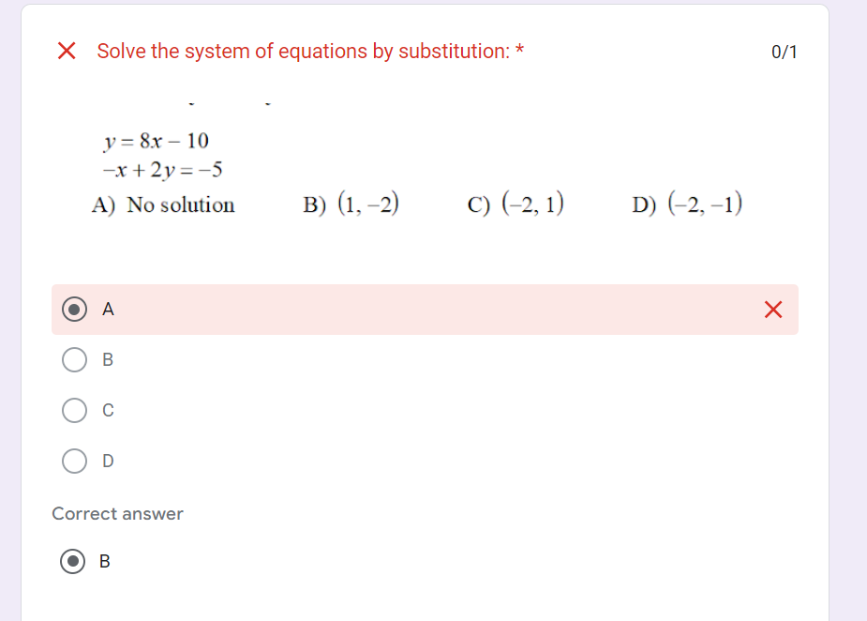

I got this wrong because I put 8x - 10 into the x variable instead of the y variable.

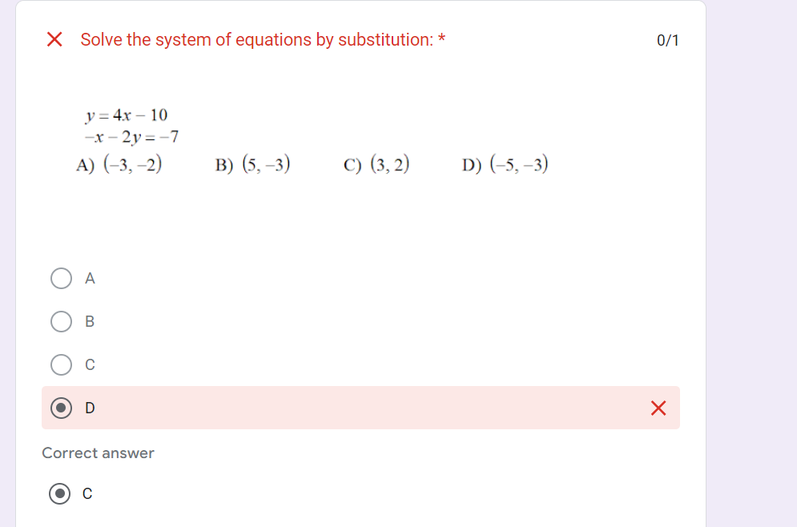

I missed this equation because I got the x and y variable mixed up.